LAB # 05

Task No 01: Write a program to calculate area of rectangle by using static method. Use parameterized constructor to assign width and height to the instance. Use Output area method which uses the static method to calculate the area.

Code:

Main:

package lab05task01;

public class Lab05task01 {

    public static void main(String[] args) {

        Rectangle r1 = new Rectangle (3,4);

        Rectangle.Display();

    }

}

Rectangle:

package lab05task01;

public class Rectangle {

     private static double  width;

      private static double height;

     Rectangle(double height, double width){

        this.height = height;

        this.width = width;

    }

     static double Area(){

         double area =height * width;

         return area;

     }

    public static void Display(){

        double Result = Area();

        System.out.print("Area: ");

        System.out.println(Result);

    }

}

Output:



Task No 02: Write a program to display Name, Enrollment Number, University Name and Semester of students that are from same university and semester using static fields and methods. (Hint: first set the university name and semester as follows:



Then use static variable counter to get unique roll numbers as follows:

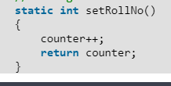

Code:

Main:

package lab05task02;

public class Lab05task02 {

    public static void main(String[] args) {

        Student s1 = new Student("John Doe", 12345);

        s1.roll_no = Student.setroll_no();

        s1.display();

        Student s2 = new Student("Jane Smith", 67890);

        s2.roll_no = Student.setroll_no();

        s2.display();

    }

}

Student:

package lab05task02;

public class Student {

    String name;

    int Enrollement_no;

    static String university_name = "bahria university";

    static int semester = 2;

    static int roll_no = 1;

    static int counter = 0;

    static int setroll_no() {

        counter++;

        return counter;

    }

    Student(String n, int en) {

        name = n;

        Enrollement_no = en;

    }

    void display() {

        System.out.println("Name is: " + name + "\nRoll no is: " + roll_no + "\nEnrollement no: " + Enrollement_no + "\nSemester : " + semester + "\nUniversity Name: " + university_name);

    }

}

Output:

Task No 03: Write a static method called printNTimes that takes an integer n and a string (in that order) as its parameters and prints the string n times. For example

Code:

Main:

package lab05task03;

public class Lab05task03 {

    public static void main(String[] args) {

        Print p = new Print();

        int n = 5;

        String alp = "Hello world!";

        p.display(n, alp);

    }

}

Print:

package lab05task03;

public class Print{

    public static void display(int n, String alp){

        for (int i = 0; i < n; i++){

            System.out.println(alp);

        }

    }

}

Output:

Task No 04: Write a static method called insult that has two parameters, a String which represents a person’s name and an integer which represents the persons age. This method should create and **return** a String which is a personal insult based on the value of the argument age that was passed. Use the following age cut offs (or variations of your choosing) for creating your insults:

Code:

Main:

package lab05task04;

import java.util.Scanner;

public class Lab05task04 {

    public static void main(String[] args) {

        Scanner sc = new Scanner(System.in);

        System.out.println("Enter your name:");

        String name = sc.next();

        System.out.println("Enter your age:");

        int age = sc.nextInt();

        InsultGenerator i1 = new InsultGenerator(name, age);

        i1.insulted(name, age);

    }

}

InsultGenerator:

package lab05task04;

public class InsultGenerator {

    private static String name;

    private static int age;

    InsultGenerator(String name, int age) {

        this.name = name;

        this.age = age;

    }

    public static void insulted(String name, int age) {

        if (age > 1 && age <= 10) {

            System.out.println("Everyone is sweet");

        }

        if (age >= 11 && age <= 17) {

            System.out.println("They are dweebs");

        }

        if (age >= 18 && age <= 20) {

            System.out.println("They are counting down to legal age");

        }

        if (age == 21) {

            System.out.println("They just made legal age");

        }

        if (age >= 22 && age <= 29) {

            System.out.println("They are counting down to 30");

        }

        if (age >= 30 && age <= 40) {

            System.out.println("They are suffering adults");

        }

        if (age >= 41 && age < 50) {

            System.out.println("They are miserable adults");

        }

        if (age >= 50) {

            System.out.println("50 you a speechless!");

        }

    }

}

Output:

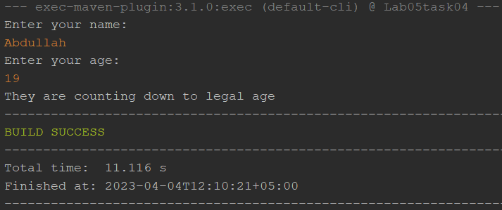

Task No 05: Write a static method called greetMe that greets you. The method should issue a prompt asking for your name, display a polite (or not so polite) greeting message and then prompt you to enter your age.

Code:

Main:

package lab05task05;

public class Lab05task05 {

    public static void main(String[] args) {

        Greeting G = new Greeting();

        G.greetMe();

    }

}

Greeting:

package lab05task05;

import java.util.Scanner;

public class Greeting {

    public static void greetMe() {

        Scanner scanner = new Scanner(System.in);

        System.out.print("What is your name? ");

        String name = scanner.nextLine();

        System.out.println("Hello, " + name + "! Nice to meet you.");

        System.out.print("How old are you? ");

        int age = scanner.nextInt();

        System.out.println("You are " + age + " years old.");

    }

}

Output:

